**Admin**

create table Admin( UserID int, Email_ID varchar(40) unique, Registered varchar(10), primary key(UserID));

desc Admin;

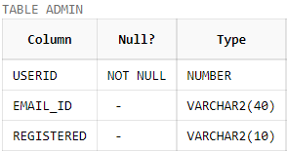

insert into Admin values(1001, 'raghuop@gmail.com','Y');

insert into Admin values(1002, 'john17@gmail.com','N');

insert into Admin values(1003, 'eren54@gmail.com','Y');

insert into Admin values(1004, 'robin66@gmail.com','N');

insert into Admin values(1005, 'sam355@gmail.com','N');

insert into Admin values(1006, 'abdulkhaliq6@gmail.com','N');

insert into Admin values(1007, 'bigil5@gmail.com','Y');

insert into Admin values(1008, 'brucewayne999@gmail.com','Y');

insert into Admin values(1009, 'kurupxxx@gmail.com','N');

insert into Admin values(1010, 'levi987@gmail.com','N');

insert into Admin values(1011, 'raju46@gmail.com','Y');

insert into Admin values(1012, 'tryionop@gmail.com','N');

insert into Admin values(1013, 'thomasshelby@gmail.com','N');

insert into Admin values(1014, 'ronaldo7@gmail.com','Y');

insert into Admin values(1015, 'peter78@gmail.com','N');

select * from Admin;

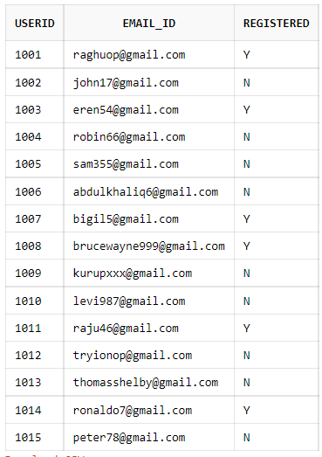

**User**

create table Users(UserID int,Email_ID varchar(40),User_Name varchar(20),primary key(UserID), foreign key(UserID) references Admin(UserID));

desc Users;

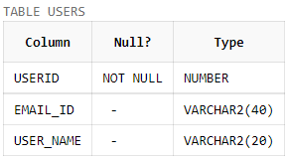

insert into Users values(1001, 'raghuop@gmail.com','Raghunandhan');

insert into Users values(1002, 'john17@gmail.com','John');

insert into Users values(1003, 'eren54@gmail.com','Eren Yeager');

insert into Users values(1004, 'robin66@gmail.com','Robin');

insert into Users values(1005, 'sam355@gmail.com','Sam');

insert into Users values(1006, 'abdulkhaliq6@gmail.com','Abdul Khaliq');

insert into Users values(1007, 'bigil5@gmail.com','Bigil');

insert into Users values(1008, 'brucewayne999@gmail.com','Bruce Wayne');

insert into Users values(1009, 'kurupxxx@gmail.com','Kurup');

insert into Users values(1010, 'levi987@gmail.com','Levi Ackerman');

insert into Users values(1011, 'raju46@gmail.com','Raju');

insert into Users values(1012, 'tryionop@gmail.com','Tryion Lanister');

insert into Users values(1013, 'thomasshelby@gmail.com','Thomas Shelby');

insert into Users values(1014, 'ronaldo7@gmail.com','Cristiano Ronaldo');

insert into Users values(1015, 'peter78@gmail.com','Peter Parker');

select * from Users;

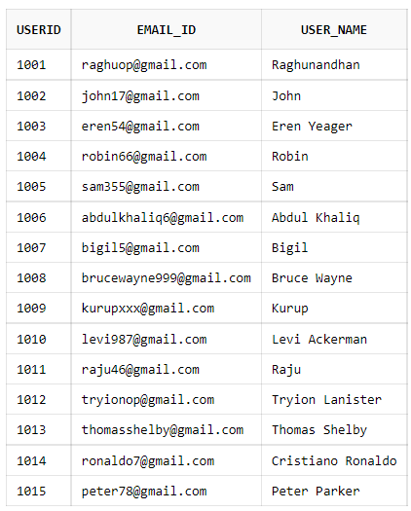

**REG Users**

create table Registered_Users (RegUId int,Username varchar(30),Email_ID varchar(40),Password varchar(30), MobileNo int unique, primary key(RegUId), foreign key(RegUId) references Admin(UserID));

desc Registered_Users;

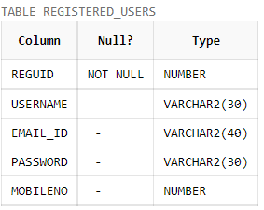

insert into Registered_Users values (1001, 'Raghunandhan' ,'raghuop@gmail.com','raghuop', 7965414655);

insert into Registered_Users values (1003, 'Eren Yeager' ,'eren54@gmail.com','eren54', 7964687475);

insert into Registered_Users values (1008, 'Bruce Wayne' ,'brucewayne999@gmail.com','brucewayne999', 9564826549);

insert into Registered_Users values (1007, 'Bigil' ,'bigil5@gmail.com','bigil5', 8235479841);

insert into Registered_Users values (1011, 'Raju' ,'raju46@gmail.com','raghuop11', 9598894655);

insert into Registered_Users values (1014, 'Cristiano Ronaldo' ,'ronaldo7@gmail.com','ronaldo7', 8922364156);

select * from Registered_Users;

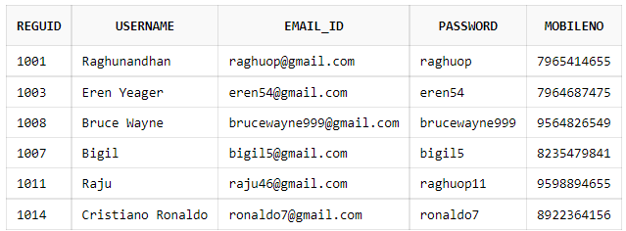

**Admin_details**

create table Admin_details(AdminID int ,Admin_name varchar(20), A_Password varchar(20), A_Email_ID varchar(40), primary key(AdminID), foreign key(AdminID) references Admin(UserID));

desc Admin_details;

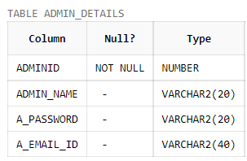

insert into Admin_details values(1008 ,'Bruce Wayne', 'darkknight', 'brucewayne999@gmail.com');

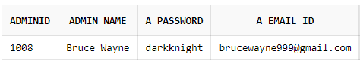

**Schemes_for_Registered_Users**

create table Schemes_for_Registered_Users(RegUId int,ActiveScheme varchar(20),primary key (RegUId), foreign key(RegUId) references Registered_Users(RegUId), foreign key(ActiveScheme) references scheme(SchemePlan));

desc Schemes_for_Registered_Users;

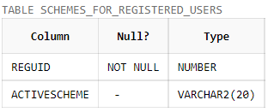

insert into Schemes_for_Registered_Users values(1008,'Basic_months');

insert into Schemes_for_Registered_Users values(1011,'Standard_months');

insert into Schemes_for_Registered_Users values(1001,'Premium_months');

insert into Schemes_for_Registered_Users values(1007,'Premium_months');

insert into Schemes_for_Registered_Users values(1003,null);

insert into Schemes_for_Registered_Users values(1014,'Standard_months');

select * from Schemes_for_Registered_Users;

